**大力游泳會 普及課程報名表格**

一項課程一張表格

表格一經遞交，如需更改／退出已報名課程，不論報名是否已被確認，均需繳付每人每項課程行政費港幣100元正

如中途插班，需繳付行政費港幣200元正；所有課程不設補課安排

**截止報名日期：課程前10個工作天（名額有限，先到先得）**

**報名流程**

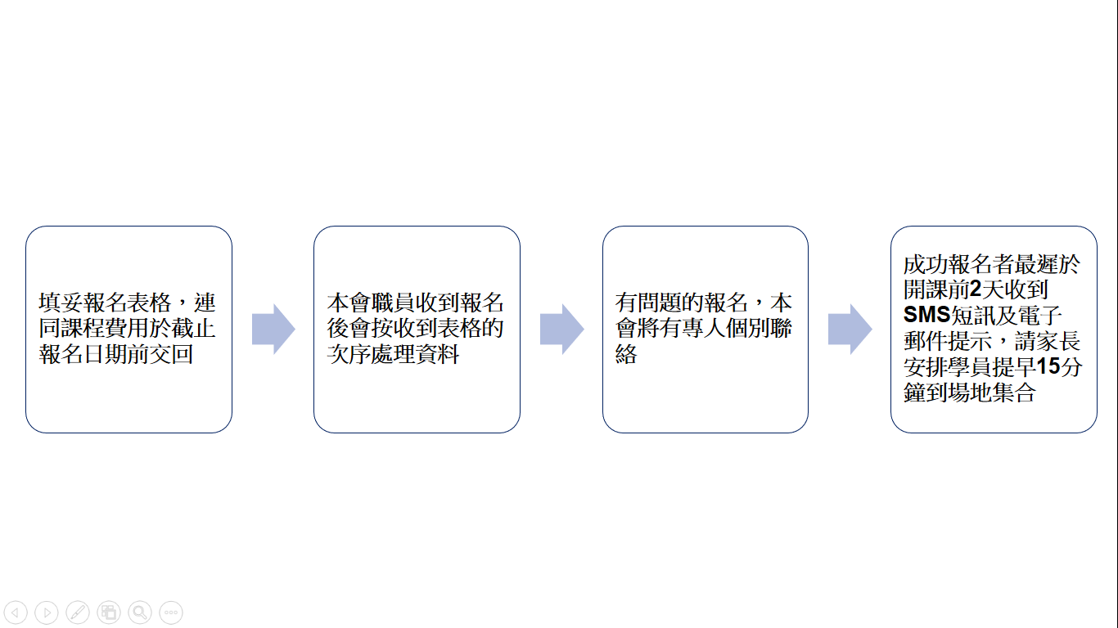

**報名方法**

1. 填妥報名表格，連同課程費用入數紙電郵（mail@daliswim.com）或傳真（2648 7268）到本會辦事處 *或*
2. 填妥報名表格，連同課程費用支票寄到本會辦事處（新界 火炭 坳背灣街45-47號 喜利佳工業大廈 10樓 N室）

|  |  |  |  |  |  |  |  |  |  |  |  |  |  |  |  |  |  |  |  |  |  |  |  |  |  |  |  |  |  |  |  |  |  |  |  |  |  |
| --- | --- | --- | --- | --- | --- | --- | --- | --- | --- | --- | --- | --- | --- | --- | --- | --- | --- | --- | --- | --- | --- | --- | --- | --- | --- | --- | --- | --- | --- | --- | --- | --- | --- | --- | --- | --- | --- |
| **第一部份 選擇課程** | | | | | | | | | | | | | | | | | | | | | | | | | | | | | | | | | | | | | |
|  | | | | | | | | | | | | | | | | | | | | | | | | | | | | | | | | | | | | | |
| **選擇課程編號** | | | | | |  | | | | | | | | | | | | | | | | | | | | | | | | | | | |  | | | |
|  | | | | | | 注意 1：如該時間內，報讀同一程度人數不足，學員或會編排與相近程度學員一同上課  注意 2：如該時間泳班人數不足，本校有權要求學員更改至其他泳班時間  注意 3：公眾泳池開放時段，家長如欲入場觀看或協助學員更衣必須自費入場  注意 4：不設任何事假或病假補課或退款  注意 5：請同時遵守各場地守則及規定。本會保留權利拒絶讓不合作的學員繼續上課而不退回課程差額 | | | | | | | | | | | | | | | | | | | | | | | | | | | |  | | | |
|  | | | | | | | | | | | | | | | | | | | | | | | | | | | | | | | | | | | | | |
| **第二部份 學員個人資料** | | | | | | | | | | | | | | | | | | | | | | | | | | | | | | | | | | | | | |
|  | | | | | | | | | | | | | | | | | | | | | | | | | | | | | | | | | | | | | |
| 中文姓名 | | | |  | | | | | | | | | 英文姓名 | | | | | | |  | | | | | | | | | | | | | | 性別 |  | |  |
|  | | | | | | | | | | | | | | | | | | | | | | | | | | | | | | | | | | | | | |
| 出生日期 | | | |  | | | | 年 | |  | | 月 | | |  | | | | | | 日 | 就讀學校 | | |  | | | | | | | | | | | |  |
|  | | | | | | | | | | | | | | | | | | | | | | | | | | | | | | | | | | | | | |
| **第三部份 聯絡資料（必須正確提供，本會將以SMS短訊及電郵發出報名確認通知）** | | | | | | | | | | | | | | | | | | | | | | | | | | | | | | | | | | | | | |
|  | | | | | | | | | | | | | | | | | | | | | | | | | | | | | | | | | | | | | |
| 家長手提電話 | | | | | |  | | | | | | | | | | | (必須能接收SMS短訊) | | | | | | | | 緊急聯絡電話 | | | | | | | |  | | | |  |
|  | | | | | | | | | | | | | | | | | | | | | | | | | | | | | | | | | | | | | |
| 電郵地址 | | | |  | | | | | | | | | | | | | | | | | | | | | | | |  | | | | | | | | | |
|  | | | | | | | | | | | | | | | | | | | | | | | | | | | | | | | | | | | | | |
| **\*\*\* 請清楚提供【電郵地址】，以便日後收取課程章程及報名資料 \*\*\*** | | | | | | | | | | | | | | | | | | | | | | | | | | | | | | | | | | | | | |
|  | | | | | | | | | | | | | | | | | | | | | | | | | | | | | | | | | | | | | |
| **第四部份 學員程度** | | | | | | | | | | | | | | | | | | | | | | | | | | | | | | | | | | | | | |
|  | | | | | | | | | | | | | | | | | | | | | | | | | | | | | | | | | | | | | |
|  | 本會現時學員 | | | | | | | | | | (學員編號 | | | | | | DLS | | | | | | | | | ) | | | | | | | |  | | |  |
|  | | | | | | | | | | | | | | | | | | | | | | | | | | | | | | | | | | | | | |
|  | 新學員 或非本會現時學員（請提供以下游泳能力） | | | | | | | | | | | | | | | | | | | | | | | | |  | | | | | | | |  | | |  |
|  | | | | | | | | | | | | | | | | | | | | | | | | | | | | | | | | | | | | | |
|  | |  | 從未習泳 | | | |  | | 懂持板踢腳15米或以上 | | | | | | |  | | 深水區踩水 | | | | | 自由泳 | 米 | | | 背泳 | | | | | 米 | | 蛙泳 | | 米 |  |
|  | | | | | | | | | | | | | | | | | | | | | | | | | | | | | | | | | | | | | |
| **第五部份 繳費方法** | | | | | | | | | | | | | | | | | | | | | | | | | | | | | | | | | | | | | |
|  | | | | | | | | | | | | | | | | | | | | | | | | | | | | | | | | | | | | | |
| 繳費金額 | | | | 港幣 | | | | | | | | | | | | | | | | | |  | | | |  | | | | | | | |  | | |  |
|  | | | | | | | | | | | | | | | | | | | | | | | | | | | | | | | | | | | | | |
|  | 銀行入數 | | | | **匯豐銀行(HSBC)戶口號碼：614-032829-838** [請將報名表連同銀行入數紙傳真/電郵到本會(入數紙上請寫上學員姓名)] | | | | | | | | | | | | | | | | | | | | | | | | | | | | | | | | |
|  | | | | | | | | | | | | | | | | | | | | | | | | | | | | | | | | | | | | | |
|  | 支票 | | | 銀行名稱 | | | | | | | | | | | | |  | | 支票號碼 | | | | | | | | | | |  | | | |  | | |  |
|  | | | | | | | | | | | | | | | | | | | | | | | | | | | | | | | | | | | | | |
|  | | | | 支票抬頭為「大力游泳會」，1項課程1張支票，期票恕不接受，本會收到支票後將即時入帳 | | | | | | | | | | | | | | | | | | | | | | | | | | | | | | | | |  |
|  | | | | | | | | | | | | | | | | | | | | | | | | | | | | | | | | | | | | | |
| **第六部份 聲明(沒簽署之報名表將不獲受理，18歲以下學員必須由家長簽署)** | | | | | | | | | | | | | | | | | | | | | | | | | | | | | | | | | | | | | |
|  | | | | | | | | | | | | | | | | | | | | | | | | | | | | | | | | | | | | | |
| 本人同意本人／敝子弟參加所報課程／活動，緊守 貴會訂明的規則，並承擔有關風險及責任。本人聲明本人／敝子弟健康狀況良好，技術水平適宜作上述課程／活動，而且不會因參加 貴會課程／活動所引致的傷亡及任何損失等，向 貴會或 貴會職員追討責任賠償。本人確認所填報的學員出生日期正確無誤，並明白若未能提供正確的出生日期，將會導致學員團體意外保險不能生效。 | | | | | | | | | | | | | | | | | | | | | | | | | | | | | | | | | | | | | |
|  | | | | | | | | | | | | | | | | | | | | | | | | | | | | | | | | | | | | | |
| **家長/學員簽署** | | | | | | | | | | | | |  |  | | | | | | | | | | | | | | | | |  |  | | | | |  |
|  | 家長/學員姓名(正楷) | | | | | | | | | | | | | | | | |  | 日期 | | | | |  |
| 個人資料收集聲明：申請人所提供之個人資料，將用作本會內部紀錄、聯絡、通訊、發放最新消息及執行特別衛生措施時使用。若申請人不欲接收這些資訊，請將學員姓名、登記電話及相關聯絡資料，電郵至mail@daliswim.com | | | | | | | | | | | | | | | | | | | | | | | | | | | | | | | | | | | | | |
|  | | | | | | | | | | | | | | | | | | | | | | | | | | | | | | | | | | | | | |
| **Office Use Only** | | | | | | | | | | | | | | | | | | | | | | | | | | | | | | | | | | | | | |
| In-coming Date | | | | |  | | | | | | | | (Mail/Fax/Email) | | | | | | | | |  | Processed by and date | | | | | |  | | | | | | | |  |
|  | | | | | | | | | | | | | | | | | | | | | | | | | | | | | | | | | | | | | |